**Calculator running screenshot**

1. Start up with initialization

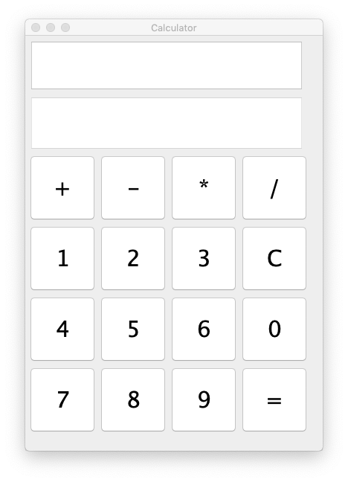

1. Click number buttons the first number :

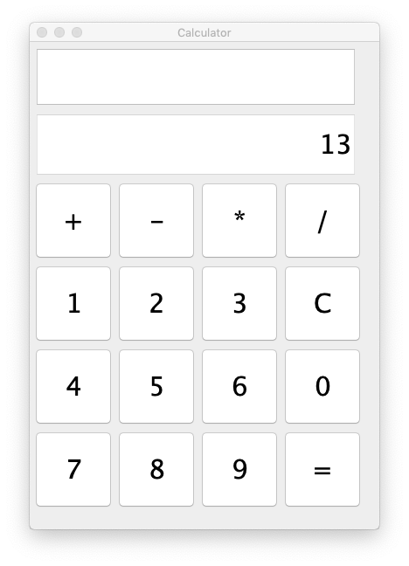

1. Choose the operation by click the button and input the second number

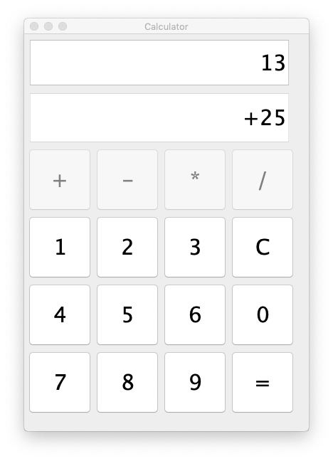

1. Click “=” to calculate the result; And “C”to clean the input line.

